Linguistics
Linguistics is used to project nodes as natural language sentences. The projection is defined by patterns that describe how a node of a specific concept is projected. The pattern consists of phrases, of which there are a few different flavors. In the following paragraphs we will describe these different flavors.
- LiteralPhrase a single word or symbol
- PropertyRef the value of a property
- ChildLinkRef the value of a child
- ReferenceLinkRef the target of a reference
- NodeRef a node that is referenced through some code
- Sequence sequence of one or more phrases
- Choice a choice of phrases, depending on conditions
- AuxPatternPhrase use an auxiliary pattern
- FeaturePhrase set linguistic feature to be applied in a phrase
- VerbPhrase a verb phrase whose word order and conjugation is
determined by the linguistic features
- VerbInsertion insert an additional verb in a phrase
- NounPhrase a phrase consisting of a determiner, adjectives and
a noun
- AdverbialPhrase an adverbial phrase
- SubjectPhrase insert a subject into a phrase
- Noun a special kind of literal phrase that signifies a noun
- NounForm a noun that is derived from an existing model element
- Adjective the adjective that is derived from an existing
model element
- Determiner the owner of a noun
- Article the article that is appropriate for a noun
- DefiniteArticle the definite article appropriate for a noun

LiteralPhrase
A literal phrase consists of a word in between a pair of single quotes. For example, 'indien'. The word occurs in the projection (without the quotes). Normally, words are separated by a space, but if a literal is to be used to project punctuation characters, one can set the punctuation as either left or right or both in the inspector. This will suppress the space on the corresponding side of the word. For instance, a comma literal ',' will have punctuation left.

PropertyRef
A property ref is used to project the value of a property. For instance, if we have a concept NumeriekeLiteral with a property waarde that contains the value, we can simply select the property as a phrase. The property ref is shown in the pattern editor as the name of the property in italics. Eg. waarde.

ChildLinkRef
To project the pattern of a child (or the children) in an aggregation link, one uses a child link ref. The phrase projects the pattern for each child interspersed with some additional phrases that can be added using intentions ‘Add Prefix’, ‘Add Postfix’ and ‘Add Separator’.
Depending on the cardinality there are different forms:
- The pre and post phrases are projected before and after the children whenever there is at least one child
- The separator phrase is shown in between children.
For instance, the following ChildLinkRef for the link init has a pre phrase 'met' and separator ','.
'met' init-','
This could render something like “met a, b, c”
Separators can be any phrase, or they can be a special SeparatorPhrase. A Separator Phrase consists of two parts separated by /. The first part is placed between all but the last pair of children. Typically, the first part is a comma. The second part is shown between the last two children. This makes it easy to generate phrases like “a, b, c en d” using a separator phrase -','/'en'.

ReferenceLinkRef
For references of a node, one can use a reference link ref. The pattern used for the reference is shown above the name of the reference
name
attribuut->

NodeRef
Sometimes information needs to be rendered that is not directly associated to a child or reference node. In such cases we can use a NodeRef. In the inspector we can specify a node name, its concept and some baseLanguage code that can be used to obtain the node.
adjective
voorloop->
The inspector will show the code for obtaining the node.
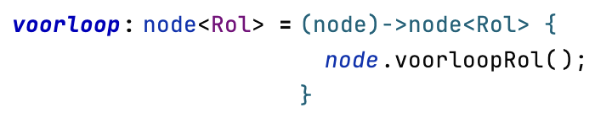

Sequence
Using a sequence, one can put several phrases after each other. For example,
links 'plus' rechts

Choice
A choice can be used to select different alternatives depending on conditions (guards). To insert a choice, enter “|”. An example of a choice is the following.
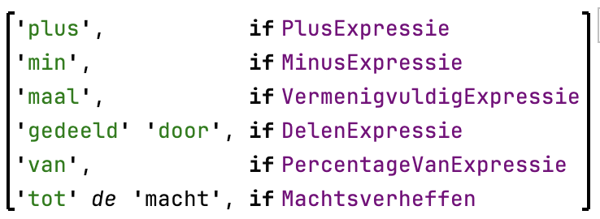
Here, the different operator names are chosen depending on the concept of the node being rendered. In section on Guards, below, we will explain the different ways in which the conditions of the choice can be specified. If none of the cases of a choice are selected, then nothing will be rendered.

AuxPatternRef
Next to the possibility to define a linguistic pattern for a concept, we can also define named auxiliary patterns. These auxiliary patterns van be referenced by name from other patterns using an AuxPatternRef.

FeaturePhrase
So far, we have just discussed phrases that have to do with grammatical constructions that are common for any kind of language (programming or natural). Such constructions stem from the theory of context-free languages. Natural languages, however, are not context free, so we need some additional mechanisms. Contextual information is governed by, so called, features. Currently, we distinguish the following:
- Tense. This can be ‘present’, ‘simple past’ and ‘past perfect’. When the tense is past perfect one can also define an auxiliary verb. For instance, the verb ‘stellen’ in singular, third person past-perfect tense with auxiliary verb ‘worden’ is rendered as “wordt gesteld”.
- Cardinality. Either ‘single’ or ‘plural’.
- Word order. Can be ‘verb-object’ or ‘object-verb’.
- Person. ‘First’, ‘second’ or ‘third’.
- Specificity. Either ‘definite’ or ‘indefinite’.
- Gender. This can be ‘common’ or ‘neuter’. In principle, we could divide ‘common’ in two sub-genders ‘male’ and ‘female’, but that distinction is not so relevant in Dutch, and the situations in which this distinction does make a difference are not used in RegelSpraak.
The features can influence the way in which phrases are rendered. Therefore, a phrase can be wrapped in a feature phrase which shows itself as a small superscript ‘F↓’ after the phrase (which is shown in a box with a light blue background). In the inspector one can set one or more features to be applied in the wrapped phrase.
An example:
With the cursor on the ‘F↓’, the inspector shows:
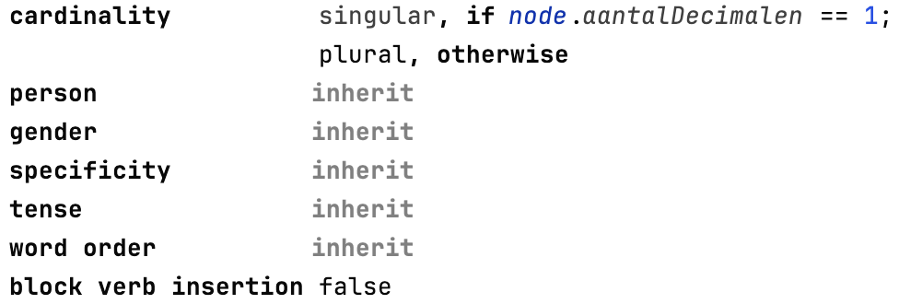
This means that the feature phrase only determines that cardinality feature, and the other features are passed on from the parent phrase.
The value of a feature can be specified as a literal (‘singular’, ‘plural’, ‘present’, etc.) or using a feature switch. A feature switch is similar to a choice, but selects feature values rather than different phrases.
In the following paragraphs we will discuss the various phrases that are influenced by these features.

VerbPhrase
A verb phrase consists of a verb and, optionally, an object and/or a preposition. In the editor, the verb is shown according to the local features. If the verb phrase has an object or a preposition these are shown after the verb in between parenthesis. E.g.
is ('leeg')
The order in which these two are rendered depends on the ‘word-order’ feature. The verb itself is rendered according to the cardinality, person and tense features. The verb phrase above van be rendered as “is leeg”, but also as “leeg is”, “leeg zijn” or even “leeg is geweest”.
A verb phrase can also have a preposition. For example, the sequence
links moet (berekend worden^{F↓} - 'als' rechts)
contains a verb phrase with the verb “moeten”. This verb phrase has an object that is also a verb phrase “berekend worden” , and it has a preposition “als rechts”. The verb phrase “berekend worden” is wrapped in a feature phrase that causes it to be rendered as past perfect tense with auxiliary verb “worden”.
Verb phrases also allow for insertion of external phrases (see below).

VerbInsertion
For constructions such as consistency rules, we use a verb like ‘moeten’ to signify that a certain sentence is obligatory. Linguistically, the structure of an obligation is similar to that of a statement, but the additional verb is inserted into it.
criterium
moet↑
For example, when the “is leeg” phrase above is rendered inside a verb insertion it may come out as “moet leeg zijn”. The inserted verb takes over the role of the main verb in the verb phrase, and the object is extended by the plural of the original verb.

AdverbialPhrase
Sometimes we need to insert not just a verb into a verb phrase, but an entire sub-sentence. This can be done using an adverbial phrase. For instance,
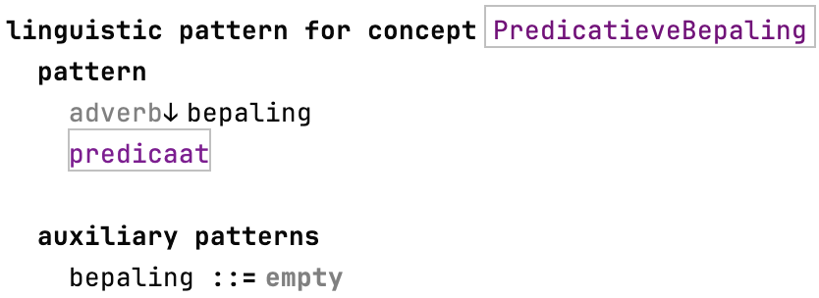
Here, an adverbial phrase inserts bepaling into the pattern for predicaat. The auxiliary pattern bepaling is to be determined (overridden) by the sub-concepts of PredicatieveBepaling. This may result in rendering “is gedurende de gehele maand leeg”, when bepaling is rendered as “gedurende de gehele maand” and predicaat itself would be rendered as “is leeg”. An adverbial phrase can be made conditional using the “Add Guard” intention.

SubjectPhrase
A sentence usually has a subject—the person or object that the sentence is about.
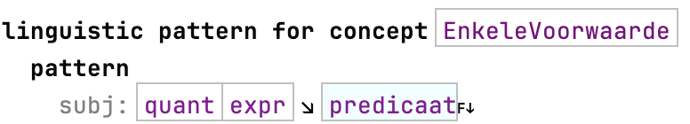
A subject phrase can be used to make explicit which part of a sentence is the subject. Knowing which part of a sentence is the subject is relevant for determining the word order in cases where questions, or passive sentences need to be rendered. Currently, RegelSpraak does not support such cases. So, one can in many cases just use a sequence to insert the subject phrase before the verb phrase. However, subject phrases do make a difference to how elliptic sentences are rendered (see section on Ellipsis) and future extensions of Alef may also make use of it.

NounPhrase
A noun phrase consists of a determiner, some adjectives and a noun. The forms of various words in a noun phrase may depend on features of the noun. When these words are just placed one after another in a Sequence, these dependencies cannot always be derived automatically. When we put them in a noun phrase, however, we can use such dependencies to derive the correct forms. The noun phrase separates the deteriner, adjectives and noun using slashes.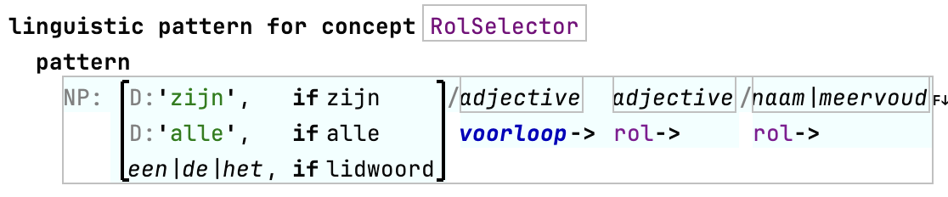
This pattern may render “een groot huis”, as well as “het grote huis”, depending on the definiteness feature. Thus, the gender of the noun (which is neuter) influences they in which the adjective is conjugated.

Noun
A noun is a particular kind of word that denotes some object. It can be rendered in singular and plural forms, and it has a gender that determines what kind of definite article (“de” or “het”) belongs to it. In the example above in the paragraph about feature phrases, we already showed an example. The word “decimalen” was a noun. In the inspector one can determine the singular and plural forms and also define its gender.
singular decimaal
plural decimalen
gender common
Notice that either the word ‘singular’ or the word ‘plural’ is bold. This determines the default cardinality of the noun. This default can be changed by clicking on the corresponding cardinality.
Apart from phrases that are explicitly denoting a noun, certain concepts of the language to be rendered can also be declared as nouns (for instance, object types and attributes). This is done using the interface INoun.

NounForm
To render a node that implements the INoun interrface, one can use a NounForm-phrase as in the following example. Here, the reference link ref rol is rendered using a noun form ‘naam|meervoud’ (as shown in the figure showing a noun phrase).

Adjective
An adjective is a particular kund of word that specifies a quality of an object. Adjectives will be conjugated depending of features (definiteness, gender, cardinality). Examples are “groot” and its conjugate “grote”; “bijzonder”/”bijzondere”, …
A concept can be declared as representing, or having, an adjective by implementing the interface IAdjective.

Determiner
A determiner is a word that can fill the role of an article in a noun phrase. Typically, words like “zijn” or “alle”. To put such words in the first position of a noun phrase they have to be declared as being a determiner. A determiner is shown as a literal with “D:” in front of it. (see example above).

Article
The example above, also shows an article (‘een|de|het’). Nouns and references to INouns will automatically select “de” or “het” depending on the gender of the noun. The noun to which the article belongs is searched to the right of the article, or if it occurs inside a ReferenceLinkRef whose target is a subconcept of INoun, then it assumes that it is that target.

DefiniteArticle
If one does not want the option for an article to be indefinite (‘een’), one can use a subconcept DefiniteArticle.

Guards
Choices among phrases or switches in feature phrases are determined by evaluating guard expressions. There are different kinds of guard expressions:
- BoolPropGuard
- SubconceptGuard
- ModelAccessGuard
- GuardRef
- AndGuard
- OrGuard
- NegatedGuard

BoolPropGuard
You can select a boolean property of the concept of the pattern as a guard.
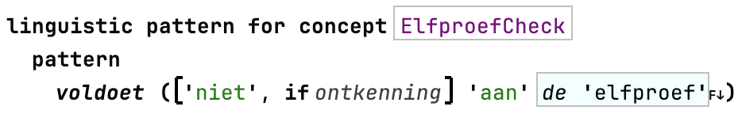
For instance, the boolean property ‘ontkenning’ of the Ontkenbaar interface concept can be used in the pattern for ElfproefCheck (because it implements Ontkenbaar).

SubconceptGuard
In the example in the section about Choice, we’ve already shown a few SubconceptGuards. With subconcept guards, one can specify a pattern for a concept and several of its subconcepts and have something specific for only one of the subconcepts (and its subconcepts).

ModelAccessGuard
To inspect nodes one can define guards using baseLanguage. These guards cannot be used directly in choices and feature switches. Instead a linguistic pattern contains a guards section in which such guards can be defined as NamedGuards. Entering model access guards starts with typing “{“. When the body of the guard contains more than one statement, brackets will be shown around the body. Within the body one can refer to the node being rendered through the node parameter.
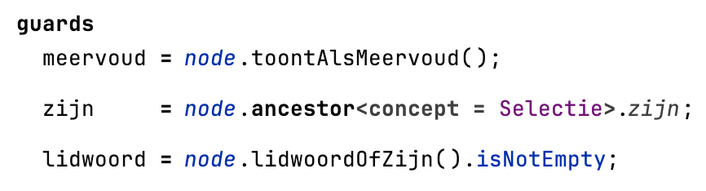

GuardRef
To use a guard that is defined in the guards section of a pattern, you refer to it using a GuardRef.

And-, Or- and NegatedGuard
You can combine guards using boolean operators and (&), or (|) and not (!). For instance,
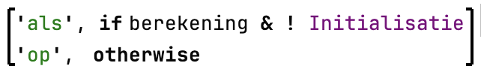

Verbs
Verb phrases require a verb. In the examples that we showed in the section about VerbPhrase and VerbInsertion, we showed simple references to verbs (instances of the concept JustAVerb). Sometimes, however, we need to select the verb depending on some properties of the node. For this, we can use ChoiceOfVerb. This concept like to Choice and FeatureSwitch, allows the specification of a few different verbs depending on guards.
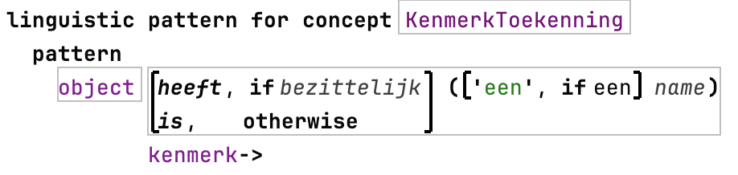
Another way to specify verbs dynamically is using a ReferenceToVerb. This is needed when verbs can be specified by the user and some reference link points to a verb (an instance of a concept that implements the IVerb interface. Currently, this does not occur in RegelSpraak, but there are plans to extend it with verb phrases with verbs that can be added by the user.

Ellipsis
A linguistic phenomenon that is hard to specify using the different types of phrases, guards and features is ellipsis. In natural language, when similar phrases are listed in the same sentence, one usually omits reoccurring words. For instance, it is unusual to write “hij is belastingplichtig, hij is meerderjarig en hij heeft een partner”. More commonly, one would write “hij is belastingplichtig, meerderjarig en heeft een partner”.
For this purpose, one can specify that a ChildLinkRef for a link with 0..n or 1..n cardinality should be rendered with ellipsis. For this, use the intention “Add Ellipsis”. A keyword “ellipsis” will appear in the editor.
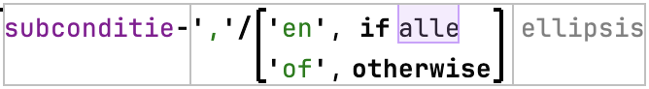
The elliptic rendering will omit reoccurrences of subjects (specified as subject phrase) and verbs.

